Adopted: February 27, 2025
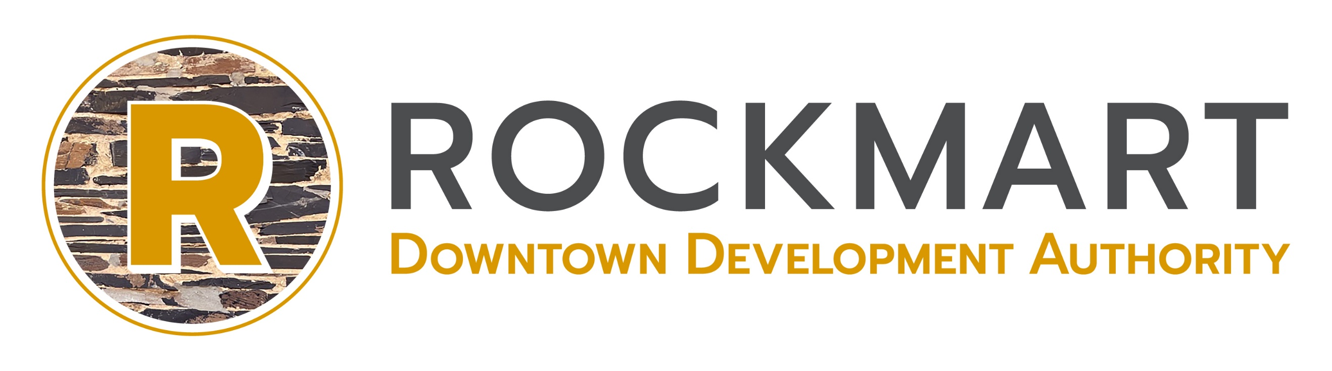
2025 PROGRAM OF WORK
Downtown Development Authority of the City of Rockmart
Board of Directors meet on the Fourth Thursday of the month at 8:30am 133 S Marble Street (Nov/Dec 3rd Thurs)
MISSION: To develop and promote a prosperous downtown supporting business, cultural, historic, and recreational assets.
VISION: To be an economically vibrant resource where the past and present stand side by side and citizens and visitors alike experience a thriving, livable city center with a diverse marketplace.
GUIDING PRINCIPLES: We believe in dedication, integrity, and transparency; Therefore, we shall maintain purposeful economic development practices that ensure a vibrant and preserved historic city center.

TRANSFORMATION STRATEGY
Maintaining Authenticity (Preservation of downtown’s-built environment)
Beautification Initiatives, Design and Parking (Improve the visual appeal of the historic district and enhance parking assets)

Internal Operations Executive Committee  The programs, services and resources of the Authority will be managed efficiently, ethically, and professionally.  Meetings: As needed | Organization Outreach Communication  The programs and services will be organized to maximize communication and unite supporters.  Meetings: Third Tues Bimonthly/9am | Promotion  Marketing and Events  The Downtown Brand will become a well-recognized marketing tool that focuses on the social and cultural center of activity.  Meetings: Third Wed Bimonthly/8:30am | Design  Physical Improvements  Downtown’s physical environment will be a signal for reinvestment, while supporting stakeholders and visitors.  Meetings: Second Wed Bimonthly/8:30am | Business Development  Recruitment and Retention  Downtown will be positioned to become a mixed-use development, creating a sustainable and diverse economy.  Meetings: Second Tues Bimonthly/9am
G o a l s & O b j e c t i v e s
Maintain oversite of internal operations of the organization and its resources, including, but not limited to finances, programs, and services. | Strives to promote the programs and services of the Authority. Grow participation through networking opportunities, recruitment, and communication. | Establish a recognized identity to be used as the framework for improving and promoting the assets of the historic downtown district, a unified place to shop, work, live and play | Improve the physical appearance and public amenities of downtown for community pride and increased private investment. | Position downtown for targeted investment and business retention that supports the overall vision, by understanding the economic conditions.
Management | Communication | Branding/Marketing | Guide Improvements | Development
- Oversee Annual Assessment  - Oversee Work Plan  - Budgets and Audit | - Continue bimonthly networking opportunity  - Develop New Business Welcome Program and Serve as mentor to new businesses  - Build volunteer base for projects and events and establish an ambassador program to serve as the “friendly faces” of downtown  - Host a community event to collect historic photos  - Recognize a Volunteer of the Year | - Seek opportunities to market downtown as a unified district  - Develop a Shop Local Campaign  - Install “selfie spot”  - Select Quality of Life Award  Special Events  - Seek partnerships that increase activity and offer an event grant program to encourage partners to bring events downtown  - Present Homespun Festival  - Launch This Place Matters campaign during preservation Month/May | - Seek opportunities to improve the streetscape thru amenities and signs  - Consider diverse types of lighting)  - Develop Sign Ordinance and Design Guidelines.  - Market/monitor Façade Grant Program and Develop Paint Palette  - Select Design Award  - Develop comprehensive parking signage  - Seek ordinances and programs that support Historic Preservation | - Analyze economic data  - Research / target codes for smart growth  - Identify and market financing resources.  - Develop This place is full of Potential campaign to increase awareness for vacant property  - Host open house for Real Estate professionals to showcase vacant property  - Use Heritage/Recreation tourism to dive an economic impact  - Select an Economic Partner Award

